**Music supplement to Lute News 101: The sixteen Fantasias of Giacomo Gorzanis**

This tablature supplement includes the sixteen fantasias and recercars of Giacomo Gorzanis, found in four printed lute books of his music published in Venice between 1561 and 1579,[1] with additional versions of two from manuscript sources. He was born around 1530 in Apulia (Puglia) near Bari in southern Italy, and declares in the first of his prints that he was blind (see title pages on p. 3).[2] In 1557 he is recorded in Trieste which is about 150 km round the Adriatic coast from Venice. It is also about 75 km from Ljubljana now in Slovenia, but then called Laibach, the centre of the Inner Austrian duchy of Carniola and Corinthia and the home of the dedicatees of his prints.[3] He became a citizen of Trieste around 1567, fullfilling the requirment of residency for 10 years and ownership of property, so it seems he was wealthy. He was married with two children, Domenica Giacoma and Massimiliano, and spent most of his life in Trieste. He is last recorded in 1572 or 1573,[4] and died sometime between then and the appearance of his fourth lute book published posthumously by his son, one of two known editions dated 1579.3 A manuscript of music by Gorzanis dated 1567 was probably copied in Munich, which may have been a draft for another print.[5] It was in the library of the Augsburg patrician Hans Heinrich Herwarth (1528-1583) before being acquired by the Bavarian ducal library in 1588 [D-Mbs Mus. ms. 1511a], and is dedicated to Odorico Erbert, Hans Heinrich's cousin Ulrich Herwarth (1539-1586), who was employed at the Bavarian court.[6] The dedication refers to Ulrich as patron, suggesting Gorzanis was acquainted with him, and a blind lutenist is mentioned in Munich court records in 1567.[7] In 1568 Gorzanis received payment of 40 taler from Emperor Maximilan II (r.1564-1576), who was in Vienna and Munich from August 1567 to August 1569.[8] Thus, it seems Gorzanis travelled North and was active as a musician in Bavaria. As a consequence, it is possible that he was acquainted with his near contemporary Melchior Neusidler during this time, as Melchior lived in Augsburg from the early 1550s and was patronised by another patrician family, the Fuggers. There are similarities between their fantasias and recercars, both tending towards complex polyphony and to ending fantasias with flowing passages in faster rhythms (e.g. no 5).

All four of Gorzanis' known lute books were published by members of the Gardano family in Venice. Antonio published the first three with the title *Intabolatura di Liuto* between 1561 and 1565, using the typical Gardano printers marks on the title pages known as lion and bear (see title pages on p. 3).[9] Antonio died in 1569, and the family firm was continued by his sons Angelo and Alessandro, the latter withdrawing in 1575 to set up his own press. Alessandro published Gorzanis' libro quarto with the title of *Opera Nova de Lauto*, two editions of which are known with the same title, and both with a printers mark different to the Gardano lion and bear type, and the two editions identical except for the addition of the date 1579 to the title page of one of them, the other undated. This fourth book was published by Gorzanis' son Massimiliano presumably posthumously, and it seems likely that it was no earlier than 1575, when Alessandro became independent, but it cannot be deduced whether it was before or after the 1579 edition.[10] There is no reason to assume that the four surviving prints were not a complete set with no further volumes now not known, albeit with a gap before the appearance of libro quarto possibly because of Antonio's death, Massimiliano collecting together the remaining music after his father's death, or the catastrophic events in Venice in the early 1570s.[11] However, it is curious that the surviving copy of Antonio Gardano's libro terzo (1564) predates his libro secondo (1565), suggesting that other prints of the same volumes had already been published, now not known. Furthermore, Girolamo Scotto published a libro secondo in 1563 with the same contents as Antonio Gardano's libro secondo,[12] two years earlier than Gardano's, further suggesting an earlier edition of Gardano's Libro secondo. To complicate matters further, the contents page of Scotto's libro secondo is dated 1562, suggesting it is a reprint of a now lost Scotto edition from 1562.[13] So Gardano may have first published an edition of the libro secondo soon after libro primo in 1561 or early in 1562. In addition, Scotto may have published only a single isolated volume of Gorzanis' lute solos, in collaboration or competition with Gardano, or else he published more of the known series, copies of which are now untraceable. Scotto also published two books of Napolitane by Gorzanis, one for voice with accompaniment in lute tablature in 1570, and another in 1571 for three voices.[14] Concordant versions of music in Gorzanis' prints, including two ricercars [no 1b and 3b - not edited to correct errors], are found in manuscript sources.[15]

The prints of Gardano (and the one of Scotto) include many errors in the tablature, typical of inaccurate typesetting such as tablature numbers on the wrong course and what seem like errors of omission.[16] However, the most frequent irregularities are the placement of bar lines, which make no musical sense. It is not known how the blind Gorzanis arranged for his music to be committed to paper, but it seems likely that a copyist under his direction produced proof copies for the printers, and it may be that the proofs lacked bar lines, which the printers then added, albeit with little regard for their accuracy.[17] The Slovenian Institute of Musicology has undertaken a complete modern edition of the music of Gorzanis, and two volumes devoted to the vocal music and the first book of lute solos have already been published [see footnotes 1 and 14].

The fantasias and recercars of Gorzanis, not in chronological sequence here but ordered to fit the pages unfortunately without avoiding page turns, are outstanding examples of imitative fantasias from the late renaissance.[18]

**Worklist**

1a. *Ricercar primo* [g]Gardano I 1561, sigs. H4v-I1v

1b. untitled [g] D-Mbs Mus.266,[19] f. 81r & 82r

9. *Ricercar Primo* [f] Gardano III 1564, sigs. K3r-K4r

8. *Recercar quarto* [g] Gardano II 1565, sigs. I4r-K1r

*Ricercar iiii. de j. Gor.* [g] Scotto II 1563, pp. 58-60

2. *Ricercar Secondo* [G] Gardano I 1561, sigs. I1v-I2v

5. *Recercar primo* [g] Gardano II 1565, sigs. I1r-I2r

*Ricercar i. de j. Gor.* [g] Scotto II 1563, pp. 54-55

4. *Ricercar Quarto* [g] Gardano I 1561, sigs. I4r-I4v

3a. *Ricercar Terza* [g]Gardano I 1561, sigs. I3r-I3v

3b. *Recercar* [g] [20] D-Mbs Mus.1511a, ff. 36v-37v

6. *Recercar sego[n]do* [d] Gardano II 1563, sigs I2r-I3r

*Ricercar ii. de j. Gor.* [d] Scotto II 1563, pp. 55-56

7. *Recercar Terzo* [g] Gardano II 1565, sigs. I3r-I4r

*Ricercar iii. de j. Gor.* [g] Scotto II 1563, pp. 57-58

15. *Fantasia Quinta del ditto* [F]Gardano IV 1579, sigs. B2r-B2v

*Fantasia Quinta del ditto* [F]Gardano IV ?, sigs. B2r-B2v

10. *Ricercar secondo* [c]Gardano III 1564, sigs. K4r-K4v

11. *Fantasia Prima di Misier Iacomo Gorzanis* [F] Gardano IV 1579, sigs. A2r-A3r

*Fantasia Prima di Misier Iacomo Gorzanis* [F] Gardano IV ?, sigs. A2r- A3r

12. *Fantasia Seconda del ditto* [g]Gardano IV 1579 sigs. A3r-A4r

*Fantasia Seconda del ditto* [g]Gardano IV ?, sigs. A3r-A4r

13. *Fantasia Terza del ditto* [g][21]Gardano IV 1579, sigs. A4r-B1r

*Fantasia Terza del ditto* [g]Gardano IV ?, sigs. A4r-B1r

14. *Fantasia Quarta del ditto* [d]Gardano IV 1579, sigs. B1r-B2r

*Fantasia Quarta del ditto* [d]Gardano IV ?, sigs. B1r-B2r

16. *Fantasia Sesta del ditto* [F]Gardano IV 1579, sigs. B2v-B3v

*Fantasia Sesta del ditto* [F]Gardano IV ?, sigs. B2v-B3v

*John H Robinson, February 2012*

**The complete settings of lute solos by John Dowland - Part 2: no 49 & 102**

The tablature supplement to *Lute News* 100 was devoted to the alternative versions of nine of John Dowland's lute solos. To continue the series, here are a further two items from the Dowland canon, DowlandCLM no 49 and 102.[22] No 49 is an almaine known from three quite similar versions. It was copied in French tablature for 6-course lute twice by Mathew Holmes into his first lute solo manuscript, GB-Cu Dd.2.11.[23] Neither have a title to indicate the genre or any dedication but both are ascribed to Dowland. Both are reproduced here in their original form illustrating the differences in barring of the end of the second and the entire third strain, as well as a few other minor variants. The first falls into three strains of 8, 4 and 4 bars without repeat signs, which the second version renders as 8, 3 and 5 bars. Both are different to the edited version used by Diana Poulton, who changed the corrupt barring, acknowledging Ian Harwood for the suggested reconstruction.[24] John Ward identified the continental concordance,[25] which Poulton then included in the amended inventory of the revised edition. The third version is found in a continental source, the huge D-LEm II.6.15 copied in German tablature.[26] The title translates as 'English Almaine' and is without ascription. It is copied in German tablature, halving the value of rhythm signs and using an eighth course tuned to D just once. As in most of the manuscript, the rhythm signs are quite irregular in their placement and have been repositioned editorially here. This version introduces errors, such as condensing two bars into one in bar four, but otherwise provides interesting variants and a more elaborate figuration. It is divided into two strains of 8 bars each with repeats signs between the first and second strains, and ends with two notes that lead into the repeat first time round, which should be omitted second time round.

No 102 is titled Praeludium and ascribed to Dooland in Philip Hainhofer's lute book [D-W Guelf. 18.7].[27] This manuscript includes three unique pieces ascribed to Dooland or Doolant [DowlandCLM no 101-103], which Poulton describes as 'possibly derived from compositions by Dowland, but hardly convincing in the form in which they appear in the MS'.[28]

**Worklist[29]**

**49. Almaine[30]**

a. GB-Cu Dd.2.11, f. 38r *Jo: Dowlande*

b. GB-Cu Dd.2.11, f. 47r *J: D.*

c. D-LEm II.6.15, p. 479 *Almins Engleiso*

**102. Praeludium**

D-W Guelf. 18.7 III, f. 17r *Praeludium*

*John H. Robinson, February 2012*

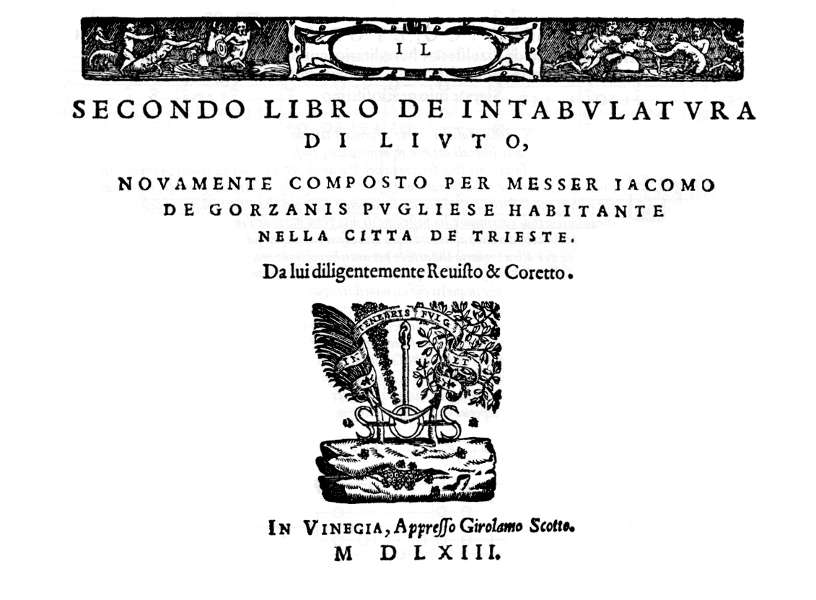

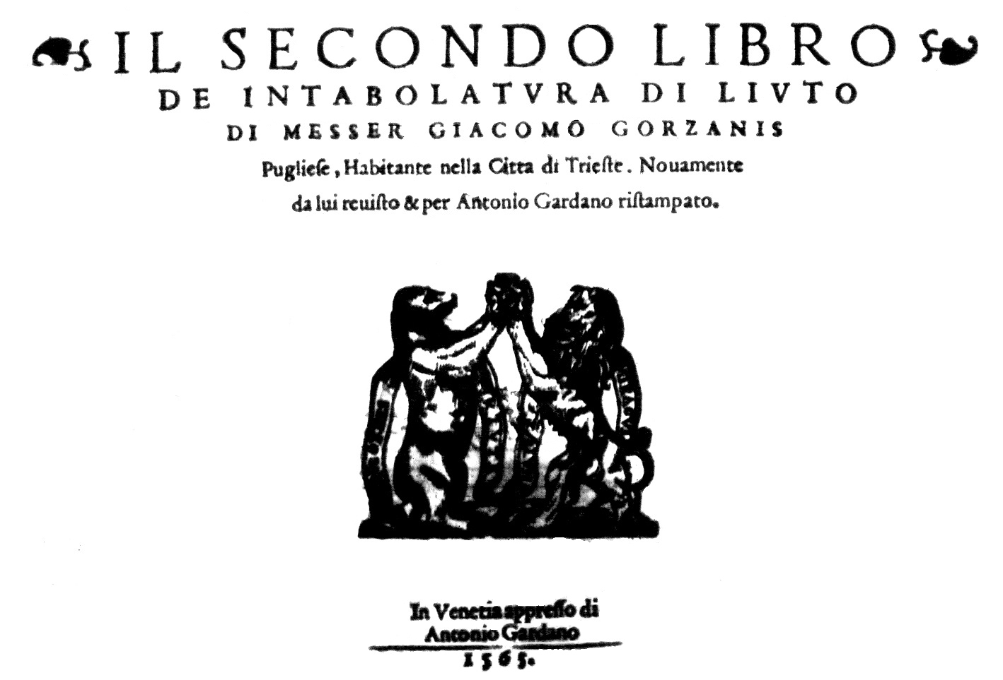

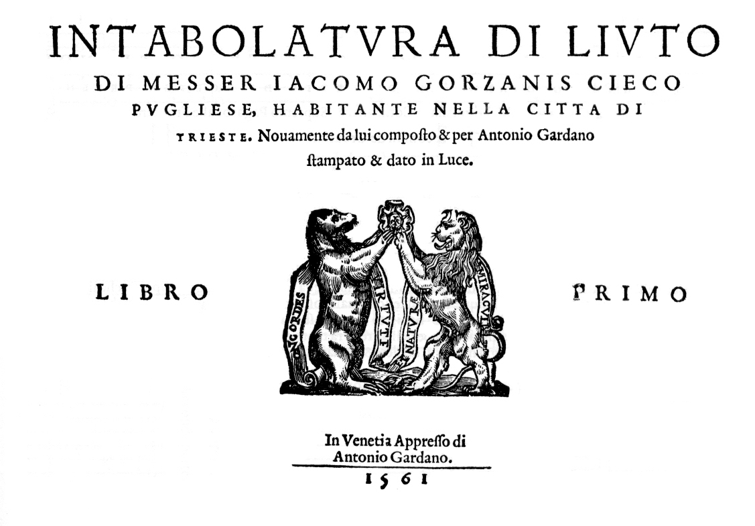

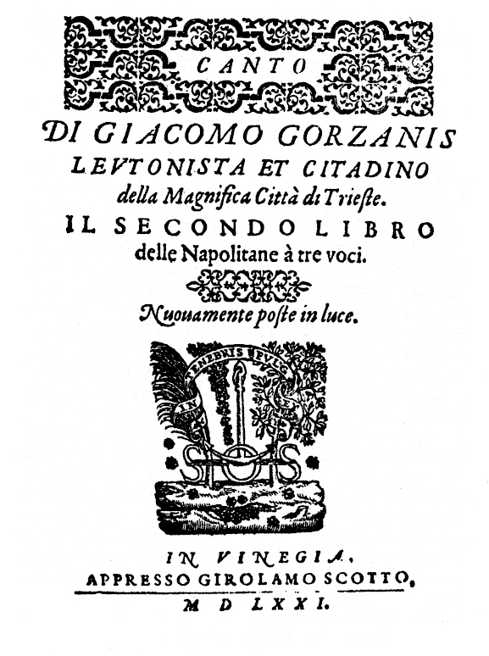

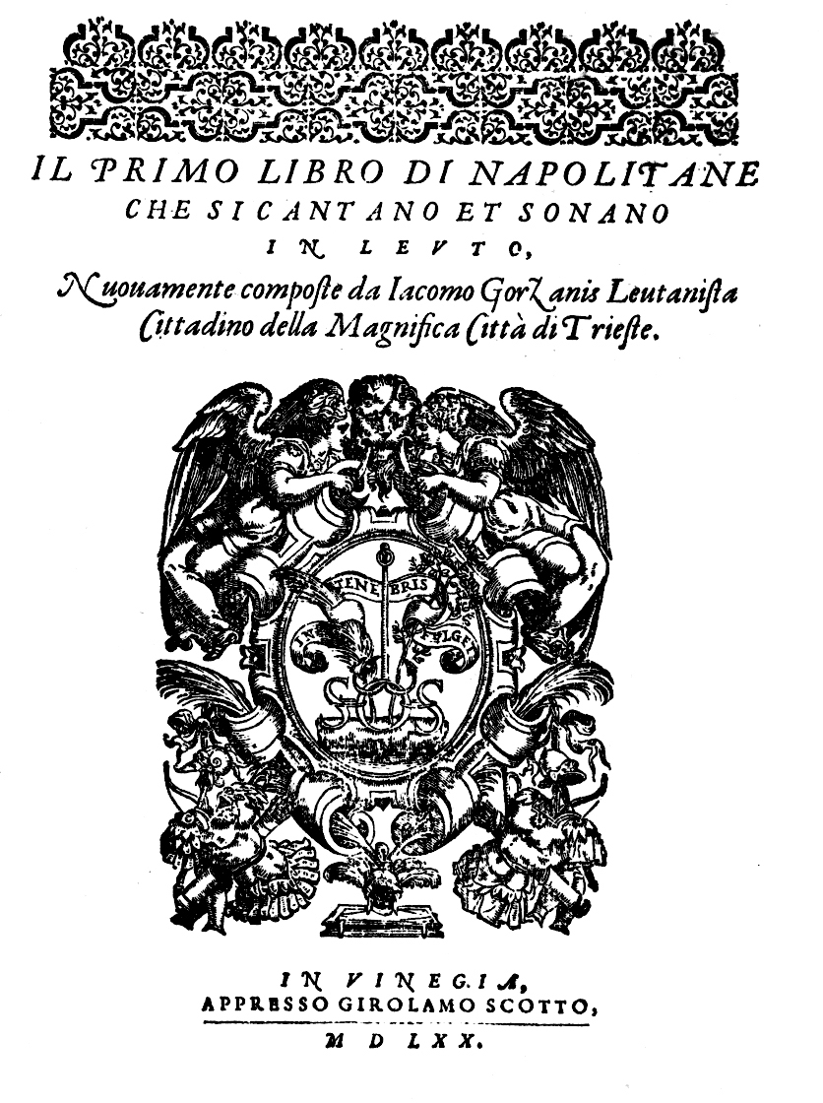

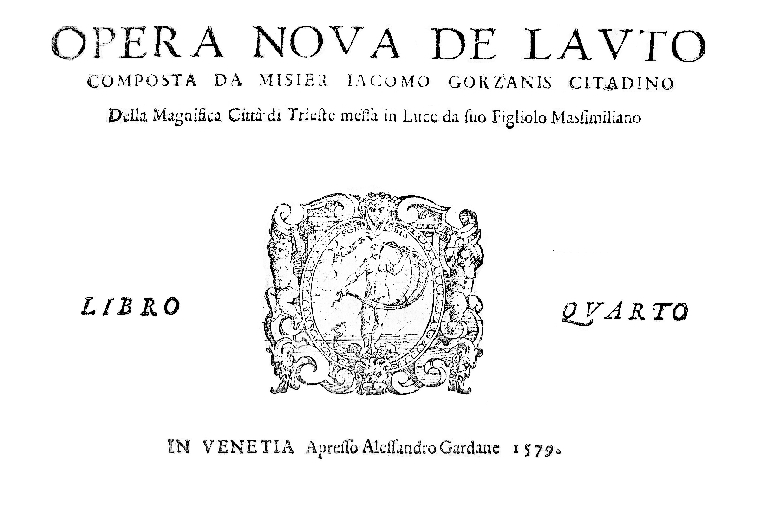

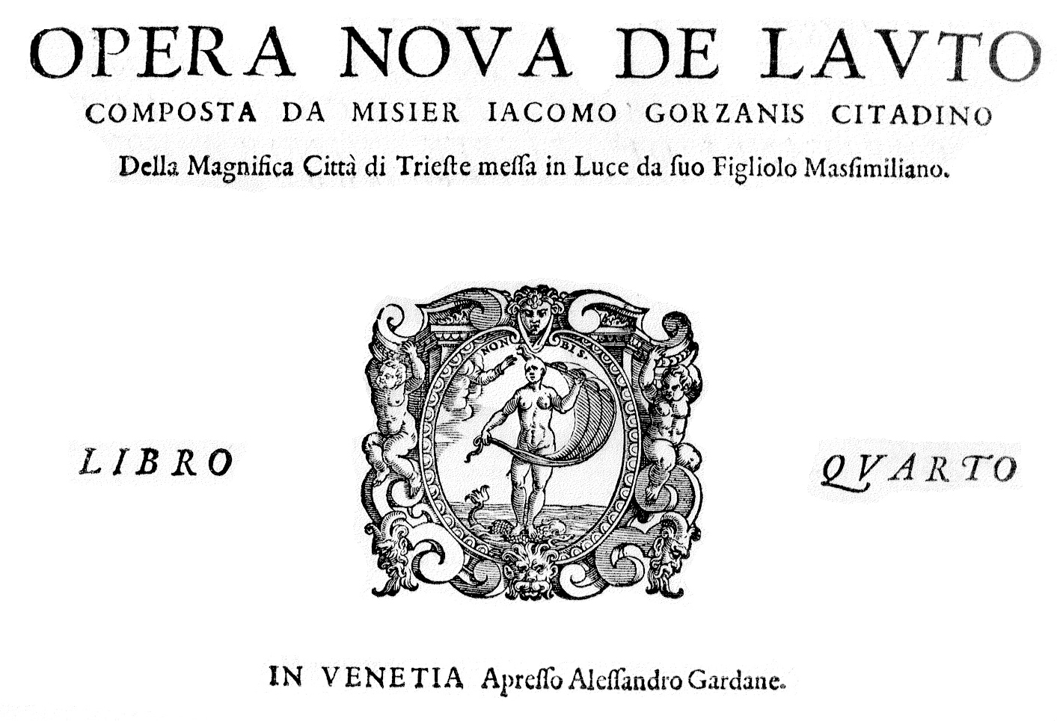



1. See title pages on p. 3. **Gardano I.** Brown 15612, RISM A/I G3031, copies in F-Pn [Rés Vmd. 73(1)], I-Gu [RARI L/7/8.1], and a copy was in Landau-Finaly library Florence. Modern edition with staff notation and Italian tablature: Alenka Bagaric (ed.) *Compositions for Lute: Intabolatura di Liuto Libro Primo (1561)*, Monumenta Artis Musicae Sloveniae 53 (Ljubljana, Muzikološki Inštitut, 2011). **Scotto** **II.** Brown 15638 and see 15622, RISM A/I G3032, copies in F-Pn [Rés Vmd. 73(2)], I-Gu [?], = **Gardano II.** Brown 15652, RISM A/I G3033, copies in A-Wn [SA.76.C.25 2 Mus 18], I-PLrubino, I-TSsc. **Gardano III.** Brown 15644, RISM A/I 3034, copies in A-Wn [SA.76.C.25 3 Mus 18], F-Pn [Rés. Vmd. 73(3)]. **Gardano IV.** Brown 156?3, RISM A/I 3037, copy in A-Wn [SA.76.C.25 4 Mus 18] = **Gardano IV.** Brown 15791, not listed separately in RISM A/I, copies in I-Bc [S.250], I-TSsc [?]. Thank you to François-Pierre Goy and Franco Pavan for information on surviving copies.
2. Hellmut Federhofer, *Musikpflege und Musiker am Grazer Habsburgerhof* (Mainz, 1967), p. 239; B. Tonazzi ‘Il cinquecentista Giacomo Gorzanis, liutista e cittadino di Trieste’ *Il Fronimo* no 3 (1973) pp. 6–21; David van Ooijen *LGS Newsletter* 35 (November 2010) pp. 4-5; Michele Carreca 'Giacomo Gorzanis and his music' *Lute News* 93 (April 2010), pp. 12-17; Arthur J. Ness *Gorzanis Giacomo [Jacomo (de)]* New Grove on-line [refers to two items by Gorzanis in the lute book of Octavian Fugger (A-Wn 18821), but I was unable to identify them]. Thank you to Peter Király for comments on my text and much additional information and references.
3. Dedications: **Gardano I 1561**: *Al molto magnifico et generoso signor il signor Giovanne Khisl detto da Kolten Prven Della Cesarea M. Dignisimo Conseglier & Supremo Pagatoralle Frontere & confini de Croatia. / D. V. S. Perpetuo Seruitor Iacomo Gorzane Sonatore di Liuto*; **Gardano II 1565**: no dedication page; Scotto II 1563: *Al molto magnifico : et generomo. Sor. Mavritio de Metriehstain detto da pizelsteten hereditario coppiero de l'Archducato de Carintia, possessore della Signatoria: de Ballnberg, Signor mio gratiosissimo.* */ D. V. S. Illvs. Perpetuo & humil seruitor Iacomo Gorzanis*; **Gardano III 1564**: *Al molto magnifico et clarissimo signor il signor vito de Dorimbergo Benemerito Caualliero Aureato. & de sua Cesarea Maesta Consigliero & dignissimo Logotenente dello illustrissimo Contado di Goritia. Signor mio Gratiosissimo. / D. V. S. Clarisima humilissimo seruitor Giacomo Gorzanis*; **Gardano IV date?**: *Alla Illustrissima Signora La Signora Rachel Malvasia Baronessa de Dorinbeg Adornech Ambasciatrice Cesarea et Capitania di Trieste Signora et Patrona Mia Sempre Colendissima. / D. V. S. Illustrissima Vmilissimo Seruitor Masimilaino Gorzanis*; **Gardano IV 1579**: = the undated Gardano IV; **Scotto Napolitane I 1570**: *Al molto magnifico Signore il S. Giorgio Kis de Koltemprvn Figliuolo del Clariss. & Generoso S. Gio. Kisl benemerito Caualliero aureato, Hereditario epifaro dell' Jllustre Contado de Goritio, & Cesareo & Archducale consegliero, & vicecapitanio della prouincia del Cragno, Patron, & Signor mio osseruandissimo. D. V. S. Seruitore Iacomo Gorzanis*; **Scotto Napolitane I 1571**: *Al Serenissimo Principe Carlo Arciduca d'Austria Sig. Sig. mio Clementissimo. D. V. Serenissima Altezza Humilissimo Seruitor & vassallo Giacomo Gorzonis Lautonista da Trieste.*
4. Erzherzog Karl von Österreich in Graz, dedicatee of Gorzanis' *Il secondo Libro di Napolitane*, made a payment in February 1572 to Gorzanis for teaching his son: 'An Einnemer zu Triest. Dem plindten Lauttenschlager Jacoben Garsonio von wegen Lernung seines Suns der musica 24 fl. zugeben. Carl.', and a blind lutenist is recorded in Graz in 1573 [Federhofer, *op cit.*].
5. Title on f. 1r: *Libro de intabulatvra di livto nel qualle si contengano vinti quatro passa mezi dodeci per bemolle et dodeci per be quadro sopra dodeci chiave. Nouamente composte con alcune napollitanae De Jacomo Gorzanis Lautenista citadino de la mag[nifi]ca cita de Trieste etc. Del mille et cinque cento et sasanta sette Annj* [1567], with the dedication on f. 1v: *Al molto magnifico signor odorico Ebert patron suo sempre obseruandissimo. etc. Della signoria vostra servitore Jacomo Gorzanis Lautanista se Trieste*, containing twelve Passa e mezo/ Saltarello pairs in all keys for both the passamezo antico and moderno, plus seven arrangements of napolitane, and a recercar [no 3b here], concordant with one in libro primo [no 3a]. A version of a Gorzanis fantasia was also copied into another manuscript in Munich, D- Mbs Mus.266 [see no 1b].
6. Arthur J. Ness 'The Herwarth Lute Manuscripts at the Bavarian State Library, Munich: A Bibliographical Study with Emphasis on the Works of Marco dall'Aquila and Melchior Newsidler' (doctoral thesis, New York University, 1984), pp. vi & 59.
7. 'Ainen Plinden Lauttenschalger so Vier Lautten [Bücher]? vnnd etliche Piecer dediciert der Zuefor meins Herrn tafel gedient 50 fl.', see Adolf Sandberger, *Beiträge zur Geschichte der bayerischen Hofkapelle unter Orlando di Lasso*. III (Leipzig, 1895), p. 31.
8. Robert Lindell, *New Findings on Music at the Court of Maximilian II*. in: Friedrich Edelmayer & Alfred Kohler, *Kaiser Maximilian II. Kultur und Politik im 16. Jahrhundert* (Wien-München, 1992), p. 233.
9. Libro primo and secondo have the 'lion and bear V [bear on the right] and libro terzo lion and bear IV [bear on the left], see Jane A. Bernstein, *Print Culture and Music in Sixteenth-Century Venice* (Oxford: Oxford University Press, 2001), pp. 135-140.
10. Howard Mayer Brown *Instrumental Music Printed Before 1600* (Harvard University Press, 1965), assumes a date in the 1560s referring to it as 156?3.
11. The outbreak of war with the Turks in 1570 and consequent famine and typhus epidemic affected Venice, followed by an outbreak of the plague severely affecting Venice 1575-1577, see Bernstein, *op. cit.,* p. 136 & 138.
12. A facsimile edition of books I-III of Gorzanis was published by Éditions Minkoff in 1981, without indicating which copies were used, and mixing libro primo and terzo of Gardano with Scotto's libro secondo.
13. See Brown, *op cit.* [1562]2.
14. See title pages on p. 3. *Il primo libro di napolitane -* Brown 15701, RISM A/1 G3035, copy in I-Fn [E.6.5.712]; *Il secondo libro delle napolitane -* RISM A/1 G3036, copies in A-Wn [CTB, SA.76.E.13]; D-As [C, Tonk 48]; F-Pn [CTB, Rés 500]; GB-Lbl [C, ex-Landau-Finaly library Florence, A.277.(6)]; I-Bc [TB, S.249] [CB, Königsberg University - lost?]. Modern edition: Alenka Bagaric (ed.) *Giacomo Gorzanis: Il Primo Libro di Napolitane che si cantano et sonano in Leuto (1570) Il Secondo Libro delle Napolitane a tre voci (1571)*, with facsimile of the primo libro: Monumenta Artis Musicae Sloveniae 51 (Ljubljana, Muzikološki Inštitut, 2007). Concordances: Primo Libro 1570 **no 7** = D-Mbs 1511a, f. 34v *Ducha venoio dir una novella napolitana de Jacomo Gorzanis*; **no 12** = D-Mbs 1511a, f. 34v *Tu ma inganato col duo dolce viso. Napolitana*; **no 13** = D-Mbs 1511a, f. 34r *Se io vegio o dormo sempre penso a tene. Napolitana*. An additional napolitane: D-Mbs 1511a, f. 35r *Tre Giorni fa che mi dicessti Ieni veni Napolitana de Jacomo Gorzanis*, and three more anonymous napolitane may also be by Gorzanis: D-Mbs 1511a, f. 35v *Damo fallano son gia stato morto*; D-Mbs 1511a, f. 36r *Bella che tini li capelli de oro*; and D-Mbs 1511a, f. 37v *Donna io te amo non mi f morire Napolitana*. Gorzanis' *Primo Libro delle Napolitane* of 1570 also supplied most of the verses for John Coperario's three-part villanellas found in GB-Lbl Eg.3665, see Christopher D. S. Field *Coprario* [*Coperario, Cooper, Cowper*]*, John* [*Giovanni*], New Grove on-line. The *Secondo Libro delle Napolitane* of 1571 was dedicated to Archduke Charles II of Austria (1540-1590) in the year of his marriage in Vienna to Maria Anna of Bavaria (1551-1608) and napolitane no 6 is titled 'Marta gentile', probably named after a famous singer known to have sung at the wedding, so it is possible that the print is related to the music performed on that occasion [see Robert Lindell 'The Wedding of Archduke Charles and Maria of Bavaria in 1571' *Early Music* 18 (1990) p. 256]. *Il Secondo Libro delle Napolitane* no 1 is found inIRL-Dtc 410/I, p. 176 *Chi in donna / giacomo Gorzanis / Sup. / Canzone* for voice and lute [modern edition: Christopher Goodwin (ed.) *The English Lute Song before Dowland*: Volume 1, *Songs from the Dallis Manuscript c. 1583* (Albury, The Lute Society, 1996), no. 6 pp. 20-21.
15. Other sources of lute solos by Gorzanis: **1.** D-Sl MS G.I.4 [Stuttgart, Bad Württenbergische Landesbibliothek, formerly Donaueschingen, Fürstlich Fürsten-bergische Hofbibliothek, *c.*1640-5], III, ff. 7v-8r *Le content Io Gazinus* [elaborate arrangement of Claudin de Sermisy's chanson *Le content est riche*; **2.** IRL-Dtc 410/I [Dublin, Trinity College Library, Thomas Dallis lute book, dated 1583], pp. 118-119 *pass’e mezzo deto il Gorzanis / Seconda p*[ar]*te* [=Gorzanis II 1563, pp. 14-15 *Passo e mezzo detto il' Gorzanis*]; **3.** IRL-Dtc 410/I, p. 132 *passamezo a*[n]*tico sul quarto ton / Secu*[n]*da p*[ar]*te* [=III 1564, sigs. H4v-I1r *Pass'e mezo antico sul quarto to*no]; **4.** IRL-Dtc 410/I, p. 151 *passomezo bellissimo Di Gorzanis* [=II 1563, pp. 40-41 *Passo e mezo bellissimo*]; **5.** IRL-Dtc 410/I, p. 153 *passa mezzo sopra il soprani Di Gorzanis* [=II 1563, pp. 41-42 *Passo e mezo bellisimo sopra i soprani*]; **6.** IRL-Dtc 410/I, pp. 154-155 untitled [=III 1564, sig. A2r-A2v *Pass'e mezo a*n*ticho primo / seconda parte*]; **7.** IRL-Dtc 410/I, p. 161 *passamezo Antico p*[er] *Gorzaneni* [=III 1564, sigs. H2v-H3r *Pass'e mezo Antico*]; **8.** IRL-Dtc 410/I, p. 163 *passamezo mod*er*no* [=II 1563, p. 8 *Passo e mezo moderno* cf. Waissel *Tabulatura* 1591, sig. I2v *8. Passemezo commune*]; and **9-41.** for the music in D-Mbs 1511a [see fn 5]. [Additional: I-CFVd , ff. 19v-21v *Passo meso Milanesse* = Gorzanis I, sigs. A2r-A4v *Passo e mezo antico primo*.
16. Editorial reconstructions have been made to adjust barring and rhythm signs. Music missing in no 1b and 3b was reconstructed from the versions in Gardano I 1561. These and the minor variants between different editions of the prints (the Gardano editions used as the primary sources) are shown in grey in the tablature.
17. The Roman printer Valerio Dorico published books of lute music lacking bar lines: *Intabolatura de Lauto di M. Francesco Milanese et M. Perino Fiorentino* (15661 recte 1546) and *Intavolatura de Leuto de Jean Matelart* (15597).
18. For example, both recercars 6 and 8 begin by repeating a 15 note theme an octave lower and then two octaves lower. For a brief evaluation see James M. Meadors, 'Italian lute fantasias and recercars printed in the second half of the sixteenth century' (doctoral thesis, Harvard University, 1984), pp. 187-205, thank you to Arthur Ness for a copy.
19. München, Bayerische Staatsbibliothek [D-Mbs], 266, are on a loose bifolio now bound as ff. 81 and 82, bars 12-34 on f. 81r and bars 35-59 on f. 82r.
20. Edited for Lute Society of America Quarterly 31, no 2 (May 1996), pp. 12-13.
21. Parody of Jaquet de Berchem's *O s’io potessi donna*, see intabulation in Melchior Neusidler *Intabolatura di Liuto* 1566, pp. 2-4 *O s'io potessi dona* and Phalèse & Bellère *Theatrum Musicum Longe* 1571, ff. 55v-56r *O sio potessi donna*.
22. Diana Poulton and Basil Lam (eds.) *The Collected Lute Music of John Dowland* (London, Faber, 1974, reprinted 1978 & 1981).
23. See the Lute Society facsimile edition, published in 2010.
24. Poulton and Lam, p. 171.
25. John M. Ward 'A Dowland Miscellany' *Journal of the Lute Society of America* x (1977), p. 69, and on pp. 32-33, Ward points out that the opening theme of this almaine is a musical commonplace, found in Dowland's first fantasia [DowlandCLM no 1] and at least ten other contemporary compositions.
26. Facsimile edition: Lübeck, Tree Edition, 2001.
27. In the text to the tablature supplement to *Lute News* 100, I said no 98 was Dowland's only prelude, omitting to include this one.
28. Poulton and Lam, p. 340.
29. Editorial alterations are shown herein grey in the tablature.
30. For Poulton's amendment to no. 49 in DowlandCLM 1974 see *The Lute* xvii (1975), pp. 63-64.